Creative Proposals Workshop + One-on-One Mentoring Sessions with Longford Artists

Artists Professional Development Workshop (In Person)

Sat 14 Nov 2026

10:00 – 13:30 – Morning
Creative Proposals & Funding Applications
Workshop for & with Longford Artists

14:00 – 17:00 – Afternoon
One-on-One Mentoring Sessions for & with Longford Artists

Venue: Small Ballroom, Longford Arms Hotel.

Writing proposals can at times be challenging and time consuming for artists and creative practitioners. It's not always easy to communicate an early stage idea and it can take time and effort to convert a blank A4 sheet into a clear and creative proposal that will, hopefully, capture the imagination of a Selection or Assessment Panel.

On top of that, our arts practices are constantly changing and evolving, which leaves us with the challenge of having to renew and refresh how we communicate what we do.

Longford Arts Office and Longford County Council has organised a workshop on writing creative proposals and funding applications. This informal and informative session is divided into two linked parts.

In the morning (Sat 14 Nov) we will be looking at writing and developing creative proposals, and all the elements that go with that challenge.

In the afternoon, a series of six one-on-one mentoring sessions are available for and with Longford Artists to pre-book, where Support Material can be submitted beforehand to be reviewed and discussed.

The Creative Proposals Workshop will include a presentation and conversation on best practice in writing proposals and funding applications, including a chance to review some recent Artist’s proposals. The workshop will aim to cover hints and tips in developing proposals; a discussion on some ‘watch-out-fors’ and common pitfalls; observations on assessment processes and selection panels as well as selection criteria; advice on sample headings to communicate ideas clearly and creatively; suggestions for Support Material, CVs and Biogs; as well as advice on time management and the dangers of procrastination.

Who can attend?
This practical workshop and one-on-one mentoring sessions are suitable for Longford Artists from all artforms, so if you are a visual artist, musician, writer, architect, performing artist or producer in the area of theatre, dance, opera etc and you have an upcoming project or funding deadline, or you intend to develop a proposal in the future, this workshop will be a good opportunity to build your capacity in this area and also to meet some fellow Longford Artists.

How to book a place?
To book a place in this workshop go to [add link]
There will be about 30 places available.

Venue
The workshop will be held at Small Ballroom, Longford Arms Hotel, N39 FK26.

Sat 14 Nov 2026

10:00 – 13:30 – Morning
Creative Proposals & Funding Applications
Workshop for & with Longford Artists

14:00 – 17:00 – Afternoon
One-on-One Mentoring Sessions x 6 – available for Longford Artists to pre-book
For these mentoring sessions, priority is given to Artists who can attend the workshop in the morning.

One-on-One Mentoring Sessions x 6 – How to Book – What to send beforehand
As part of this workshop, Longford Arts Office have organised a small number of one-on-one mentoring sessions for Longford Artists to pre-book, on a first come first served basis.
These mentoring sessions are designed so that Longford Artists – of any artform – can discuss their practice or a current challenge or question they might have etc. Each session will run for about 25 mins.
These sessions are reserved for Artists who book and attend the Creative Proposals Workshop in the morning.
Once a mentoring session is booked, Artists are asked to submit some short information beforehand, which will be forwarded to Annette to go through.

Artists can send information that they would like feedback on, for example:

- Do you have a current practice challenge or question that you want to focus on…?

Support Material – please send us some examples of your arts practice, for example:
- A current draft proposal or application for funding – 2-3 pages max
- A previous proposal or application for funding that could be discussed – that was either successful (yippee) or unsuccessful (ah no) – 2-3 pages max
- Information on the linked Funding Opportunity that you are / were applying for, such as the Funding Scheme Guidelines or Application Form etc – 2-3 pages max
- A draft or recent CV, Biog or Artists Statement – 2-3 pages max
- Documentation of your arts practice – some focused material that shares / shows what you do, for example:
  - Selected web pages are fine (rather than a full website) – or social media page (Instagram etc)
  - Jpegs x 10 – plus Image List
  - Links to 3-4 audio or video clips (total material should not exceed 10-15 minutes in length)
  - Short text, script, treatment, selection of writing practice for review (4-5 pages max)

All Artist’s Support Material for review will need to be sent to us no later than:

- 12:00 on Fri 6 Nov 2026 for the mentoring sessions on Sat 14 Nov – in person – at Longford Arms Hotel – the afternoon of the Creative Proposals Workshop
- If mentoring sessions are oversubscribed, artists who have applied correctly will be chosen at random.

Annette will spend time before these mentoring sessions reviewing the Support Material submitted by Longford Artists so that the one-on-one mentoring sessions can be focused on the Artists current practice challenge or question etc.

To book for a one-on-one mentoring sessions please email / contact artsoffice@longfordcoco.ie

Cost
The cost of the workshop is €10 with priority given to Longford Artists.

About the Workshop Leader

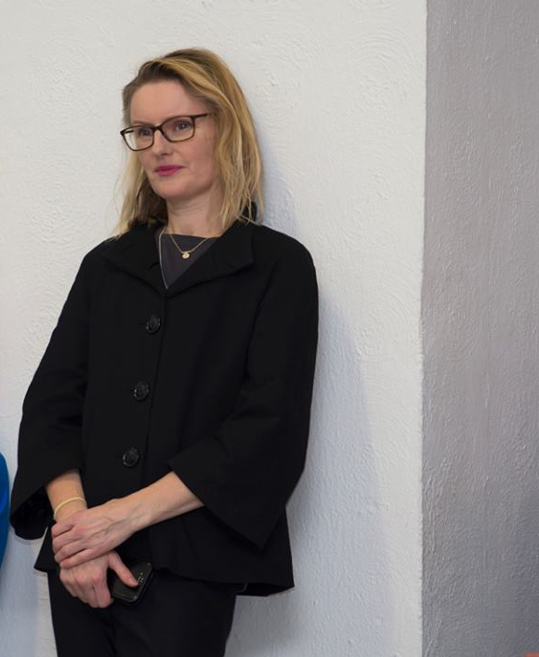
Annette Moloney (she / her) is a curator + commissioner + collaborator. She is a Public Art Specialist with over 25 years of experience, including eight years working with the Arts Council of Ireland as their National Adviser on Public Art, including the Government Per Cent for Art Scheme. Direct contact with Artists is a key part of her practice.

Examples of her curatorial practice include Skerries Art Trail, developed by Fingal County Council’s Public Art Programme, co-curated with Caroline Cowley (Fingal Deputy Arts Officer). Skerries Art Trail, funded mainly by Fáilte Ireland, included the commissioning of six new small-scale public art commissions installed along the seafront in Skerries, North Dublin. The project has linked public engagement initiatives developed with autism awareness in mind, including links with Skerries Autism Friendly Town Group, as well as links to other Local Stakeholder Groups.
Artists: Atsushi Kaga – Bennie Reilly – Liliane Puthod – Marie Farrington – Mary Conroy – Jackie McKenna

Further projects inc. working in 2015 as Cavan Curators in Residence (with Maeve Mulrennan) working directly with Artists from a range of artforms. Annette also received an Arts Council of Ireland Visual Arts Curator in Residence Award to develop endurance | resilience, a Curated @ Source project which explored the links between sport and human effort in contemporary art, located at the Source Arts Centre, Thurles, Co. Tipperary.

A Fine Art graduate from Limerick School of Art & Design and the National College of Art & Design in Printmaking, she completed a Masters in Visual Arts Practice at IADT (Dun Laoghaire Institute of Art, Design & Technology), Dublin, specialising in Curatorial Practice.

