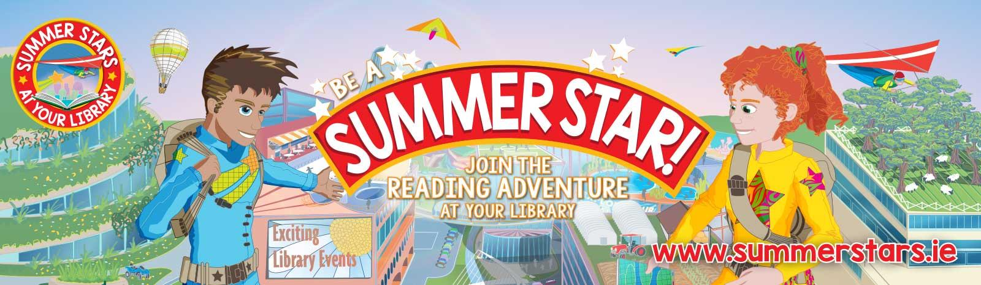
Summer fun at Longford Libraries!
The Summer Stars reading programming is running in Longford’s libraries throughout this summer. Summer Stars is a free programme open to all children. Each child who registers will join in the fun of reading lots of exciting books during the summer. Children will receive their own Summer Stars Reading Card to record their progress and the Summer Stars Reward Stamp will be added to their card for each book read.
Fun rewards will be provided along the way!
Paint your own Story!
Let your imagination run wild…Pick up a brush and paint your own Story with Stephanie.
Suitable for children aged 6-12 years.
- Drumlish Library (043 3324760) 11am, Monday 8th July
- Longford Library (043 3341124) 3.30pm, Monday 8th July
- Longford Library (043 3341124) 11am, Tuesday 9th July
- Lanesboro Library (043 3321291) 2.30pm, Tuesday 9th July
Mud Bugs!
Nature workshop for children 8-12yrs
- Longford Library (043 3341124) 11am, Monday July 8th
- Lanesboro Library (043 3321291) 2pm, Monday July 8th
- Drumlish Library (043 3324760) 11am, Saturday July 13th
Bunnyhop returns!
It’s summertime! And that means Bunnyhop and Chris Thompson are back again for some fun-loving story-telling. Suitable for children aged 3-8 years.
- Lanesboro Library (043 3321291) 3pm, Wednesday July 10th
- Ballymahon Library (090 6432546) 11am, Tuesday July 16th
- Longford Library (043 3341124) 2.30pm, Tuesday July 16th
- Drumlish Library (043 3324760) 12pm, Wednesday July 17th
- Granard Library (043 6686164) 3pm, Wednesday July 17th
Pet Talk Time!
Love your pet? Then join us for Petcare talk with Dogstrust Ireland. Suitable for children aged 7-12 years.
- Longford Library (043 3341124) 12.30pm, Monday July 8th
- Drumlish Library (043 3324760) 3pm, Monday July 8th
- Edgeworthstown Library (043 6671927) 11.30pm, Tuesday July 9th
- Ballymahon Library (090 6432546) 2pm, Tuesday July 9th
- Granard Library (043 6686164) 10.30am, Wednesday July 10th
- Lanesboro Library (043 3321291) 1.30pm, Wednesday July 10th
Teddy Bears’ Picnic!
Enjoy the Teddy Bears’ Picnic and story time with Maggie. Suitable for children aged 3-6 years.
- Longford Library (043 3341124) 11am, Saturday July 13th
- Granard Library (043 6686164) 4pm, Thursday July 18th

Ahoy Treasure!
Get outdoors this summer with our fantastic Family Fun Treasure Hunt. Suitable for children aged 6-12 years. Children must always be accompanied by an adult. As always weather permitting!
- The Mall Complex (043 3341124) 11am, Friday July 19th
Acting up with Maggi
Drama workshops age group 7-11
- Drumlish Library (043 3324760) 12pm, Wednesday July 10th
- Longford Library (043 3341124) 11am, Thursday July 11th
- Lanesboro Library (043 3321291) 2.30pm, Monday July 15th
Learn to rap with Glen
Rapping workshops with Glen Boyne suitable for children aged 10 – 14yrs
Lanesboro Library (043 3321291) 10.30am, Friday July 12th
Ballymahon Library (090 6432546) 2.30pm, Friday July 12th
Coding & IT workshops
- Lanesboro Library (043 3321291) 3-5pm, July 16th, 17th & 19th
- Granard Library (043 6686164) 2pm, July 10th, 11th & 12th
Board game battles
- Lanesboro Library (043 3321291) 3pm every Friday in July & August
Kids Movie Club
- Lanesboro Library (043 3321291) 10-12pm every Saturday in July & August

Want to win a new bike? (To the value of €200)
Explore Longford photo competition for children 4-18 yrs.
Longford Tourism and Sports Partnership in conjunction with Longford Libraries.
Email a high quality photo of a scene/attraction/town/village in Co. Longford. The competition will run from 1st July – 31st August. One photo entry per person.
Send photo as an attachment to photocompetition@longfordcoco.ie
with your name, age and details of where the photo was taken
Winning photos in each category (4-11) (12-18) will win a bike!
Please note photo entries may be used for promotional purposes. Full details of the competition are available in your local library.
Follow us on social media: @Longford Library / Longford Libraries
www.facebook.com/longfordlibraries
@Longfordlibrary

Web: www.longfordlibrary.ie
@Longfordlibrary

Or visit www.longfordlibrary.ie Tel: 043-3341124 / email: library@longfordcoco.ie
All events are free of charge. Book in your local library

